Processing Assignment 0

Save a new Processing file in M:\Students Common\Mr. Mikula\Computers 10\Processing as ‘Assign0Draw’.

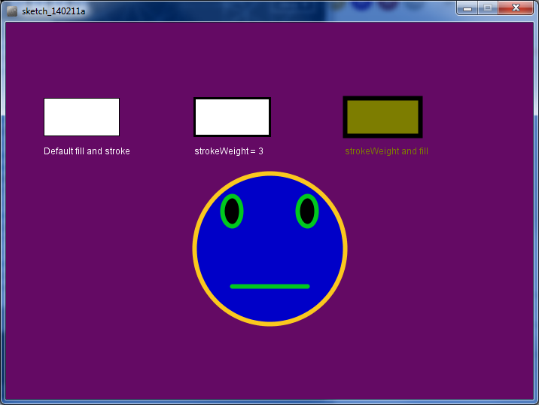

Step 1: Begin with the following code:

void setup() {

  size(700, 500);

  background(100, 10, 100);

}

void draw() {

  background(100, 10, 100);

}

Step 2: Draw three equally sized rectangles across the screen

* line them up evenly (same Y coordinates)
* spread them out so they are equally spaced

Step 3: Label the rectangles with text to match the example

Step 4: Change the stroke, strokeWeight and fill colours for each rectangle

Step 5: Draw a large circle, centred on the screen. Change the stroke, strokeWeight and fill colours as you wish.

Step 6: Draw two eyes.  Change the stroke, strokeWeight and fill colours as you wish.

Step 7: Draw the mouth.  Change the stroke, strokeWeight and fill colours as you wish.